**MNI LAB QUIZ: 1**

**Question: 1**

**Show by writing a program to swap the arrays as given.**

* **Swap array 2 data in array 1**
* **Swap array 3 data in array 2**
* **Swap array 1 data in array 3**

**Array 1= 1,3,5,7,9,11,13,15,17,19**

**Array 2= 2,4,6,8,10,12,14,16,18,20**

**Array 3= 1,2,3,4,5,6, 7,8,9,10**

**SOURCE CODE:**

org 100h

; add your code here

LEA SI,Array2

LEA DI,Array1

LEA BX,Array3

;Swapping Array 2 to 1

MOV AL,[SI]

MOV [DI],AL

MOV AL,[SI+1]

MOV [DI+1],AL

MOV AL,[SI+2]

MOV [DI+2],AL

MOV AL,[SI+3]

MOV DI+3,AL

MOV AL,[SI+4]

MOV DI+4],AL

MOV AL,[SI+5]

MOV DI+5],AL

MOV AL,[SI+6]

MOV DI+6],AL

MOV AL,[SI+7]

MOV DI+7],AL

MOV AL,[SI+8]

MOV DI+8],AL

MOV AL,[SI+9]

MOV DI+9],AL

;Swapping Array 3 to 2

MOV AL,[BX]

MOV [SI],AL

MOV AL,[BX+1]

MOV [SI+1],AL

MOV AL,[BX+2]

MOV [SI+2],AL

MOV AL,[BX+3]

MOV [SI+3],AL

MOV AL,[BX+4]

MOV [SI+4],AL

MOV AL,[BX+5]

MOV [SI+5],AL

MOV AL,[BX+6]

MOV [SI+6],AL

MOV AL,[BX+7]

MOV [SI+7],AL

MOV AL,[BX+8]

MOV [SI+8],AL

MOV AL,[BX+9]

MOV [SI+9],AL

;Swapping Array 1 to 3

MOV AL,[DI]

MOV [BX],AL

MOV AL,[DI+1]

MOV [BX+1],AL

MOV AL,[DI+2]

MOV [BX+2],AL

MOV AL,[DI+3]

MOV [BX+3],AL

MOV AL,[DI+4]

MOV [BX+4],AL

MOV AL,[DI+5]

MOV [BX+5],AL

MOV AL,[DI+6]

MOV [BX+6],AL

MOV AL,[DI+7]

MOV [BX+7],AL

MOV AL,[DI+8]

MOV [BX+8],AL

MOV AL,[DI+9]

MOV [BX+9],AL

ret

Array1 DB 1,3,5,7,9,11,13,15,17,19

Array2 DB 2,4,6,8,10,12,14,16,18,20

Array3 DB 1,2,3,4,5,6,7,8,9,10

ret

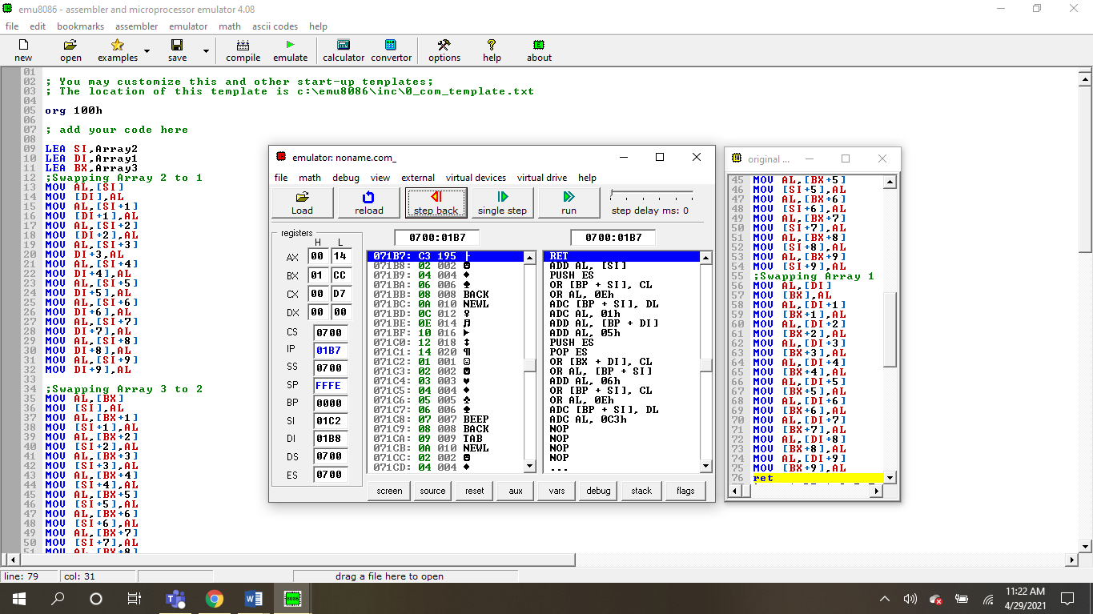

**Question: 2**

**Proceed by adding array 1 and array 3 and show the result in the array starting from**

**0450h location.**

**SOURCE CODE:**

LEA BP, ARRAY1

LEA SI, ARRAY3

MOV DI,0450H

MOV CX,10

LOOP1:

MOV AH,[BP]

MOV BH,[SI]

ADD AH,BH

MOV [DI],AH

INC BP

INC SI

INC DI

LOOP LOOP1

ret

ARRAY1 DB 1,3,5,7,9,11,13,15,17,19

ARRAY3 DB 1,2,3,4,5,6, 7,8,9,10

**Ret**

**OUTPUT:**

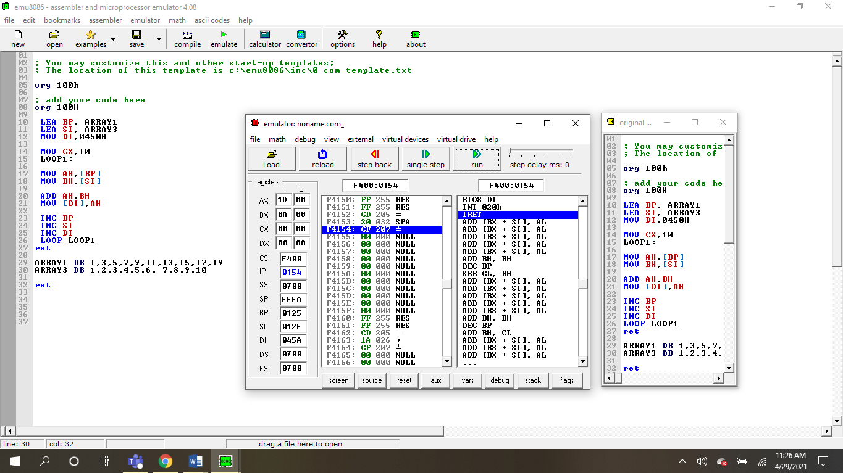

**---------------------------------THE END-------------------------------**